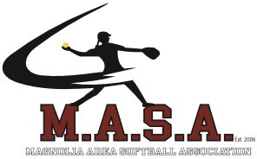

MAGNOLIA AREA SOFTBALL ASSOCIATION
A 501(c)(3) non-profit organization

FOR ADDITIONAL SPONSORSHIP INFORMATION CONTACT:
SecretaryofMASA@gmail.com
MagnoliaAreaSoftball@yahoo.com

Magnolia Area Softball Association
P.O. BOX 57
Magnolia, TX 77355

Send this completed form along with the company logo to:

SecretaryofMASA@gmail.com

Tax Deductible #36-4593575
Pay via check (to coach or mail) or
Venmo @MASA-MagnoliaSoftball


MISSION / VISION
Magnolia Area Softball Organization empowers girls ages 4-18 to discover their love for softball in a supportive and inclusive community where players of all skill levels can thrive. Through exceptional athletic experiences, mentorship, and high-quality coaching, we develop not only skilled athletes but also confident, resilient individuals who uplift and support one another. Our mission is to foster a lifelong passion for the game while instilling teamwork, character, and perseverance—helping players grow both on and off the field.

THANK YOU FOR SPONSORING!!!

 | SPONSOR A CHILD |  | DIVISION SPONSOR
 | $ 185 - ONE TIME |  | $ 1,000 – ONE YEAR
 | This includes the registration cost for one player to play for a season. |  | $ 500 – ANNUAL RENEWAL  Includes a sign along the fence near the dugout and a link with your logo on our website
 | T– BALL TEAM SPONSOR |  | SCOREBOARD SPONSOR
 | $ 250 – PER SEASON |  | $ 5,000 – ONE TIME - 5 YEARS
 | Includes a sign on the field where your team plays and a link with your logo on our website. |  | Includes custom signage on the scoreboard for a specific division along with a link with your logo on our website.
 | TEAM SPONSOR |  | DUGOUT SPONSOR
 | $ 550 – PER SEASON |  | $ 1,300 - ONE YEAR
 | Includes a sign on the field where your team plays and a link with your logo on our website. |  | Includes an 8’ X 30’ mesh banner (subject to availability, custom designs are an additional $100), and a link with your logo on our website.
 | PLAYER ENCOURAGEMENT |  | BATTING CAGE SPONSOR
 | $ 150 - O N E T I M E |  | $ 550 – FIRST YEAR
 | Includes a mini sign on the field of your team with the player’s name and personalized message |  | $ 300 – ANNUAL RENEWAL  Includes a sign at the batting cage and a link with your logo on our website.
 | IMPROVEMENT SPONSOR
 | $ 1,000 – ONE TIME
 | Includes a sign and a link with your logo on our website. |  | 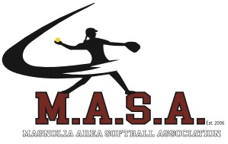
\

SPONSOR NAME AND CONTACT | DIVISION, TEAM NAME & PLAYER
___________________________________ | ___________________________________
____________________________________ | ___________________________________
SPONSORSHIP TYPE | COMPANY NAME
___________________________________ | (as you want it to appear on the sign)
 | ____________________________________
 | ____________________________________
PAYMENT AMOUNT

____________________________________ | COMPANY PHONE/EMAIL
 | (as you want it to appear on the sign)
 | ____________________________________
PAYMENT TYPE
__________________________________ | ____________________________________
SEND LOGO TO | COMPANY WEBSITE
SECRETARYOFMASA@GMAIL.COM | (as you want it to appear on the sign)
 | ____________________________________
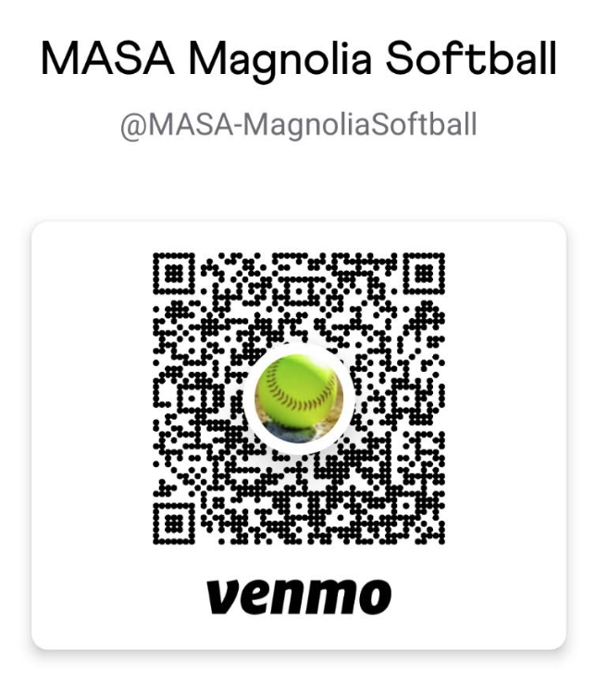 | BOARD MEMBER SIGNATURE UPON RECEIPT OF PAYMENT  ___________________________________

